CS 340 README

About the Project
This project is a full-stack application for Grazioso Salvare. It uses MongoDB to store animal shelter data from the Austin Animal Center (AAC) and a web-based application so the user can view and filter the animals.

Motivation
Grazioso Salvare is a company specializing in training dogs for search-and-rescue operations. They are not database users that know the operations needed to retrieve or enter information. Providing them with an easier to use interface increases their productivity.

Getting Started
To reproduce this project, first import the Austin Animal Center Outcomes dataset (aac_shelter_outcomes.csv) into MongoDB. Next, create an authenticated MongoDB user named aacuser in the admin database with readWrite permissions for the aac database. Update the connection variables in CRUD_Python_Module.py with the appropriate username, password, host, and port.
The Python module uses an AnimalShelter class to connect to the database. The Create method uses insert_one() to insert a document and returns a Boolean indicating success or failure. The Read method uses find() to query documents and converts the resulting MongoDB cursor into a Python list. The Update method uses update_many() to update a single or multiple existing entries. The delete method uses delete_many() to delete a single or multiple existing entries.
During development, I encountered challenges with the Jupyter Notebook retaining an outdated version of the imported module. This was fixed by restarting the Jupyter kernel.

Installation
The following software and libraries are required to develop and run the CRUD Python module:
- Python 3: Used to develop the object-oriented CRUD module. Download and install Python from python.org.
- MongoDB: A NoSQL database used to store and manage the AAC animal shelter records. Install MongoDB Community Server to host the database.
- PyMongo: The Python driver used to connect to MongoDB and execute database operations. Install using pip install pymongo.
- MongoDB Database Tools: Provides mongoimport, which is used to import the AAC dataset from its CSV file into MongoDB.
- Jupyter Notebook: Used to execute the Python testing script and display the results of the Create and Read operations. Install using pip install notebook.
- Codio: The virtual development environment provided by SNHU. It contains the project files, dataset, and tools needed to complete the coursework without requiring a separate local installation.
- Dash and JupyterDash: Frameworks used to build and run the interactive web dashboard.
- Plotly Express: Used to create the interactive pie chart showing the distribution of animal breeds.
- Dash Leaflet: Used to display animal locations on an interactive map.
- Pandas: Used to convert MongoDB query results into DataFrames for processing and displaying data.
PyMongo also provides the BSON library used to work with MongoDB's ObjectId values. Python libraries can be installed using pip if they are not already available in the environment

Usage
The application supports database operations through a CRUD class and provides a dashboard for viewing and analyzing the animal shelter records.
CRUD Python Module
Create: Accepts a dictionary of animal information and inserts a new record into MongoDB. Returns True when the insertion succeeds and False when it fails.
Read: Accepts a dictionary containing search criteria and returns matching MongoDB documents as a Python list.
Update: Accepts a query and a dictionary of updated values. Updates matching records and returns the number of documents modified.
Delete: Accepts a query and deletes matching records. Returns the number of documents deleted.
Interactive Dashboard
The application initially displays all animals in an interactive data table. A pie chart and map are displayed below the table. A dropdown menu provides four filtering options:
- Water Rescue
- Mountain or Wilderness Rescue
- Disaster or Individual Tracking
- Reset (All Animals)

When a rescue category is selected, the data table updates to display matching records. The pie chart also updates to show the distribution of breeds within the filtered results. To improve readability, the chart displays the 10 most common breeds and groups any remaining breeds into an “Other” category.
The map displays the geographic coordinates of the selected animal record. Users can select an animal in the data table to view its location and additional information on the map.
Selecting Reset restores the dashboard to its original, unfiltered state.

Reset (All Animals)
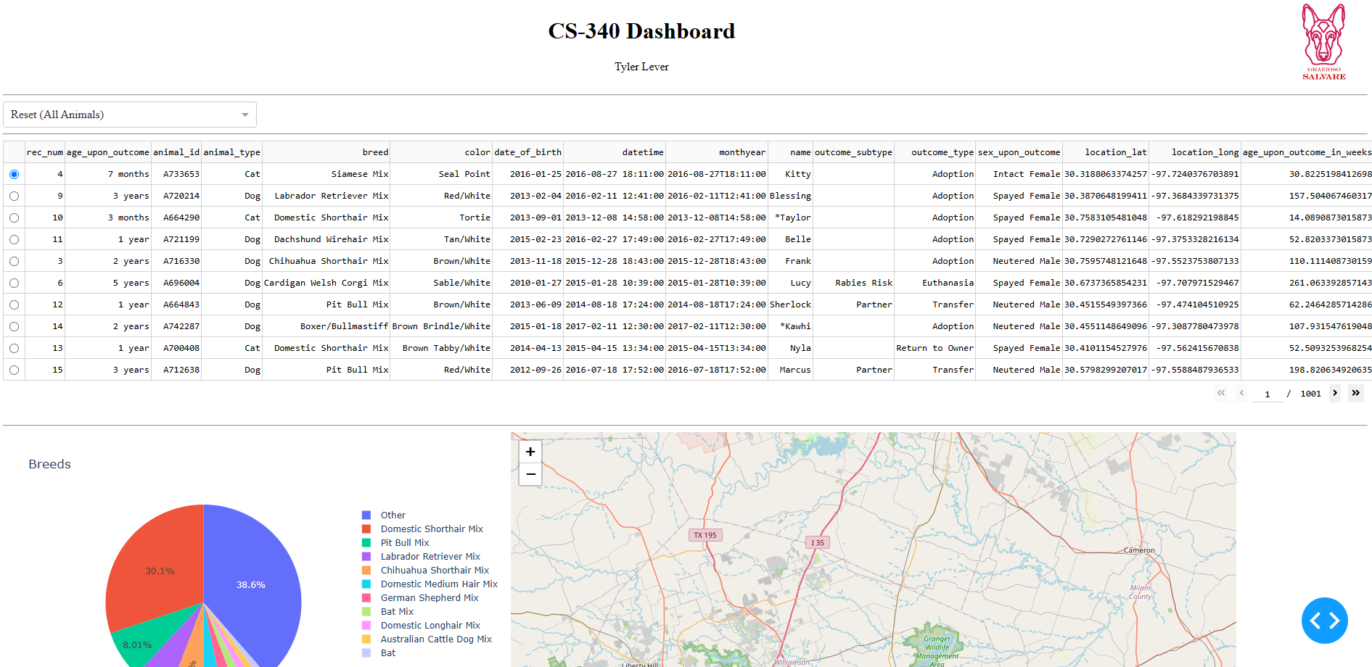

Water Rescue
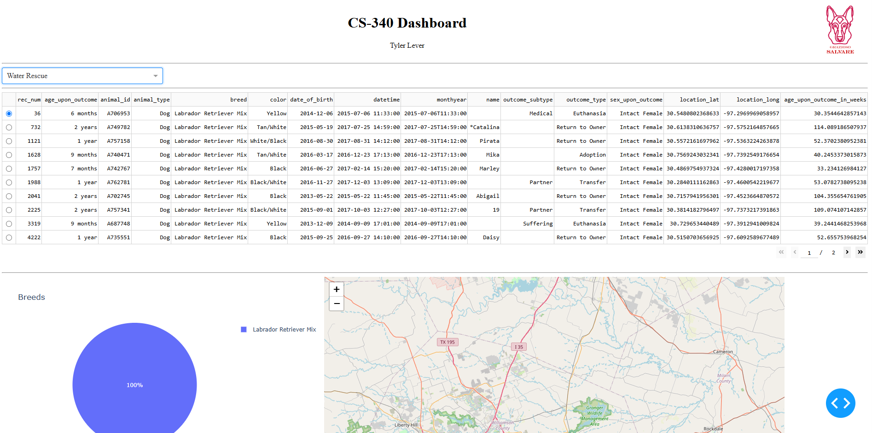

Mountain or Wilderness Rescue
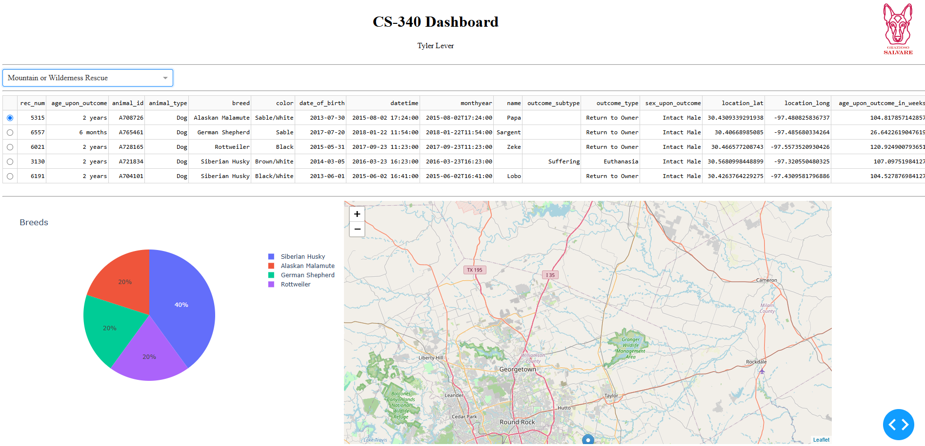

Disaster or Individual Tracking
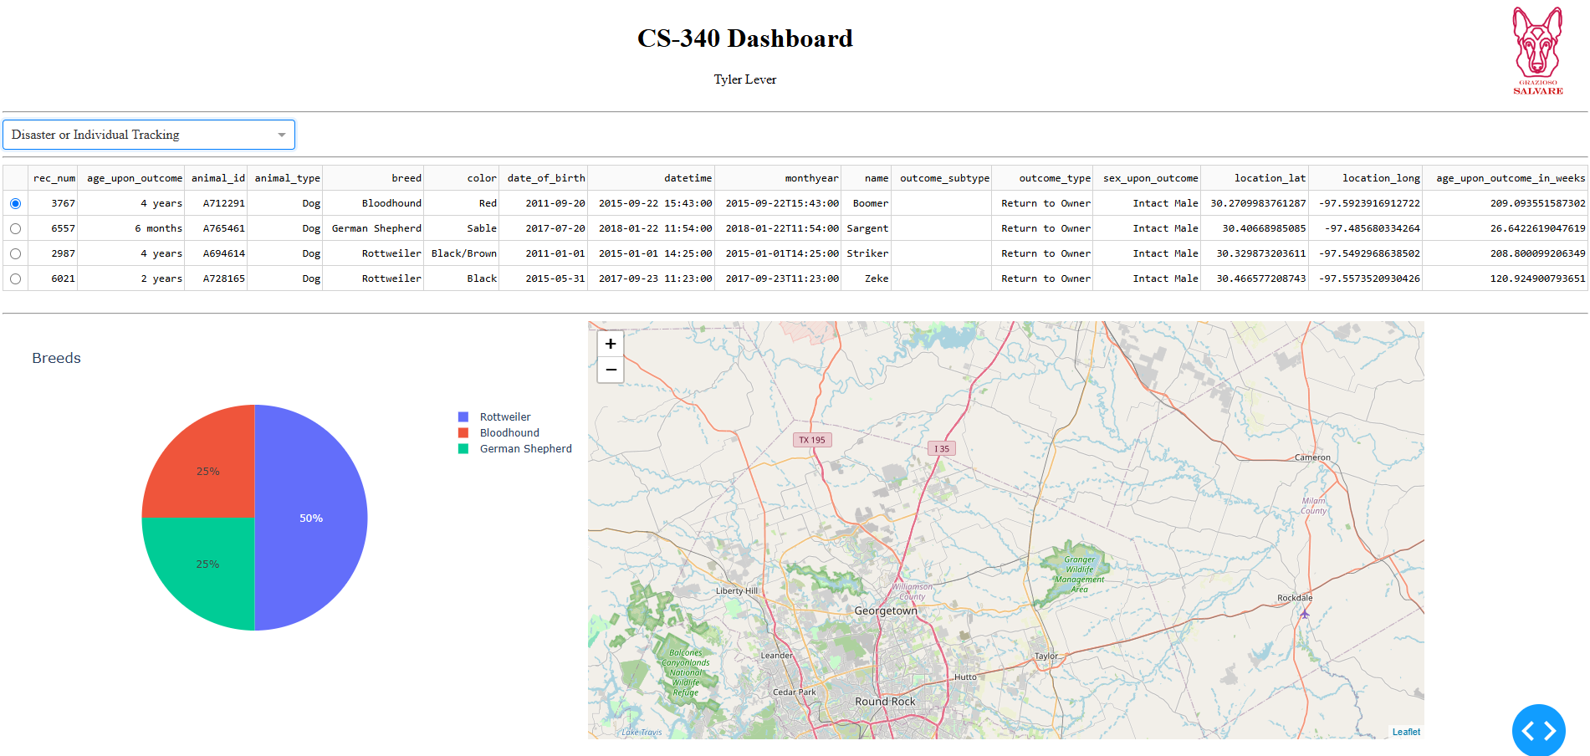

Code Example
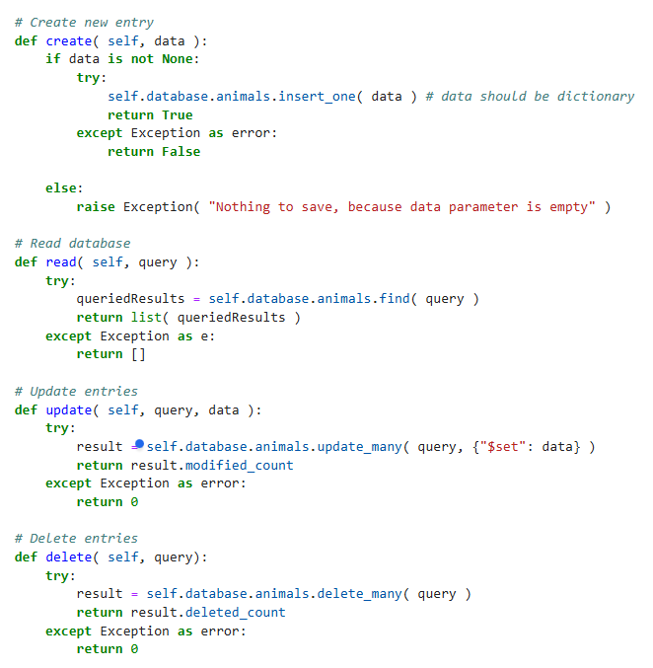

Tests
- Initializing
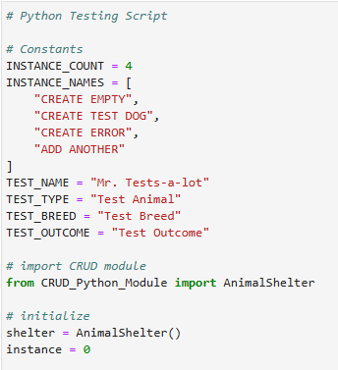

- Run each instance
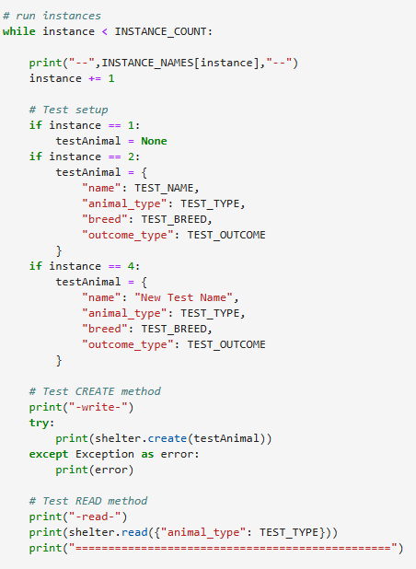

- Update entries
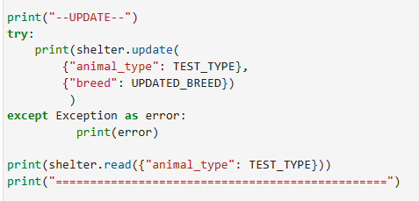
- Delete entries
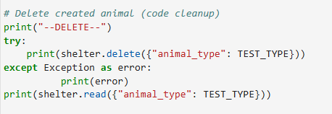

- Results
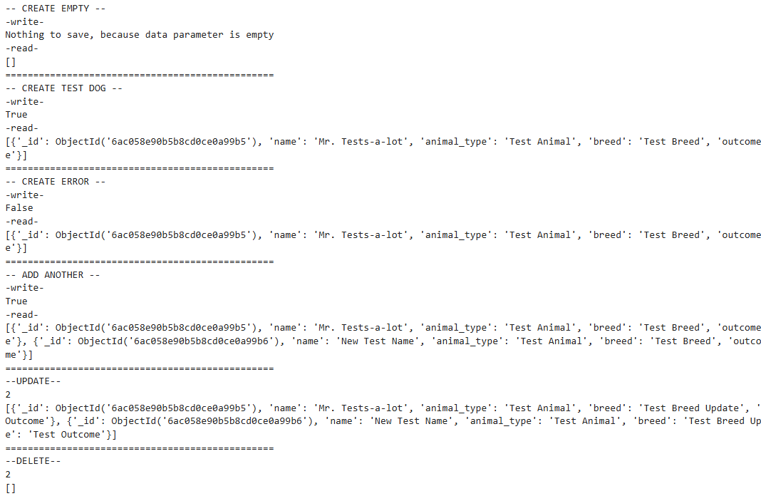

Import CSV
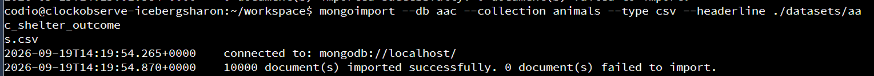

Create aacuser
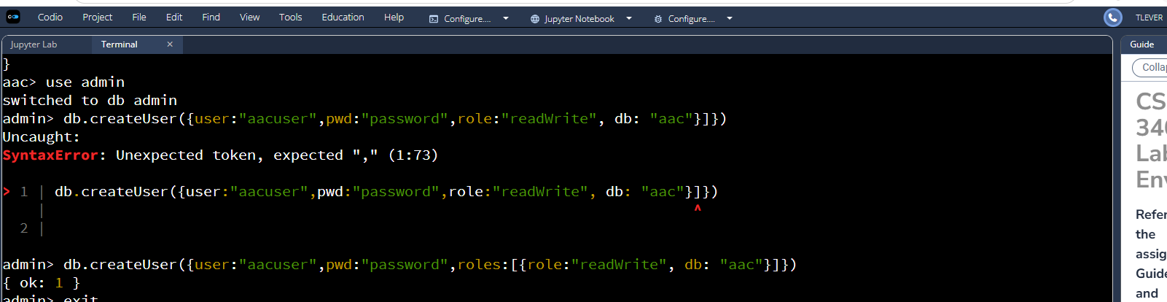

Log in as aacuser

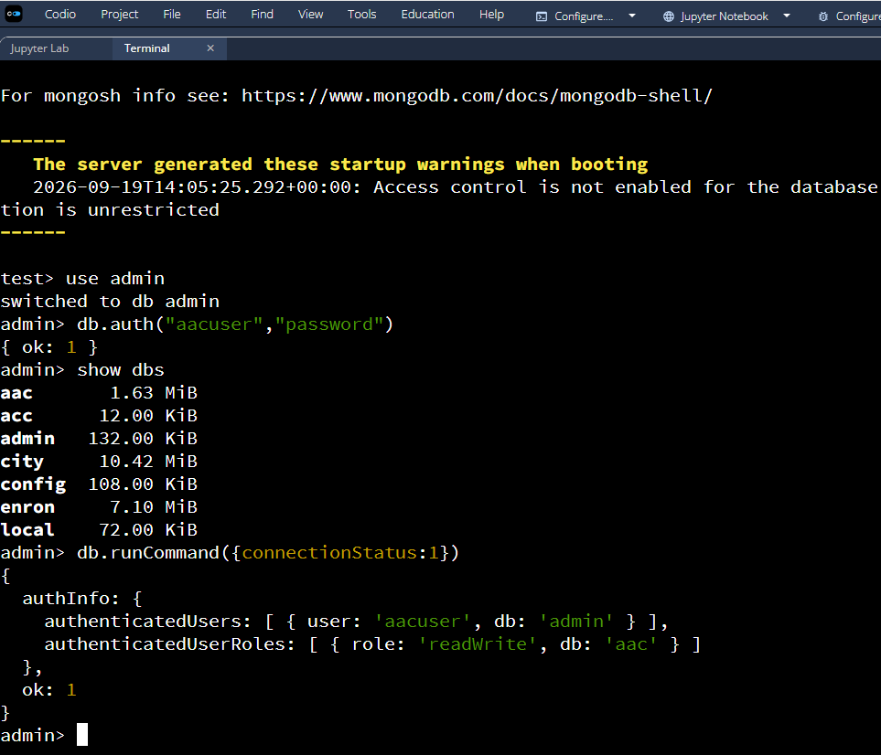

Roadmap/Features
Completed Features
- MongoDB database containing Austin Animal Center animal shelter records.
- Python module supporting Create, Read, Update, and Delete operations.
- Interactive dashboard displaying animal shelter data.
- Dropdown menu for filtering dogs by search-and-rescue category.
- Interactive data table with pagination.
- Pie chart displaying the distribution of animal breeds.
- Geolocation map displaying selected animal records.
- Grazioso Salvare branding and developer identification.

Future Improvements
  - Export filtered animal records to CSV for further analysis.
  - Add additional filtering options, such as individual breeds, age ranges, or animal outcomes.
  - Allow users to search for individual animals by name or identification number.
  - Provide additional charts to visualize other characteristics of the shelter population.
  - Improve the dashboard layout for different screen sizes.
  - Add the ability to perform Create, Update, and Delete operations directly through the dashboard.

Contact
Tyler Lever | tyler.lever@snhu.edu

